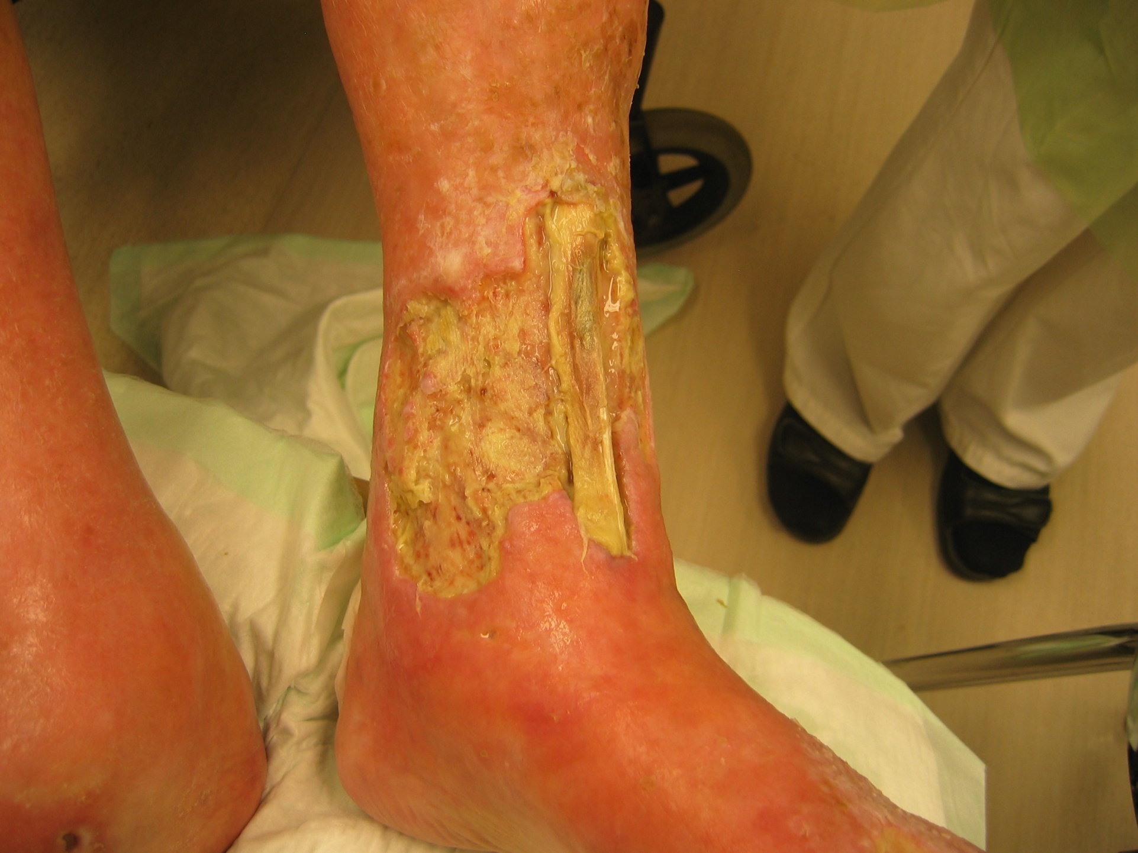
Figure 1a – c shows the same patient

A woman aged 73 with severe rheumatoid arthritis, reduced peripheral circulation and a painful hard-to-heal ulcer was treated with negative pressure as a last option before amputation. Assessment showed ABPI of 0.7 and ulcer size 76.8 cm² measured by digital planimeter. Treatment with negative pressure was initiated after surgical revision of the necrotic tendon. Dressing changes were carried out in primary care three times a week by special trained staff at Blekinge Wound Healing Center.

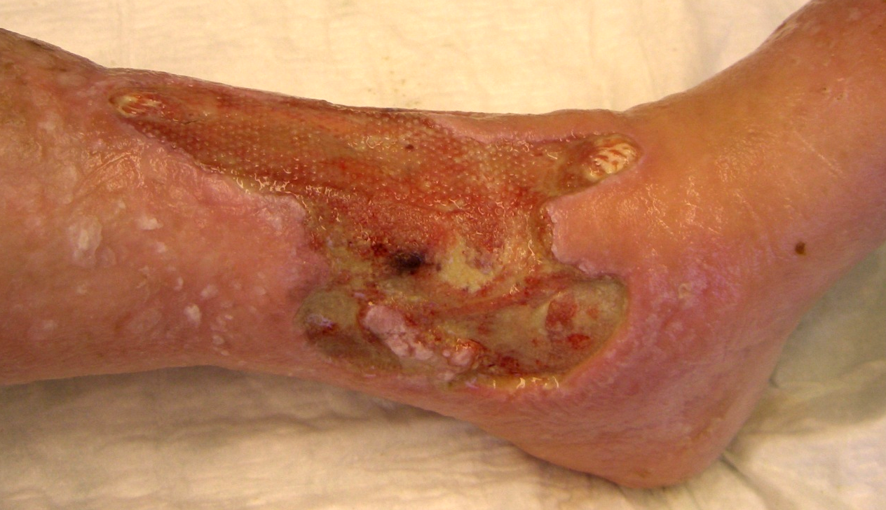
Figur 1b.

Three weeks’ treatment with negative pressure resulted in the formation of granulation tissue and reduction of edema. Thereafter we used hydrocolloid dressings and reduced compression therapy for another 13 weeks until the ulcer was completely healed.

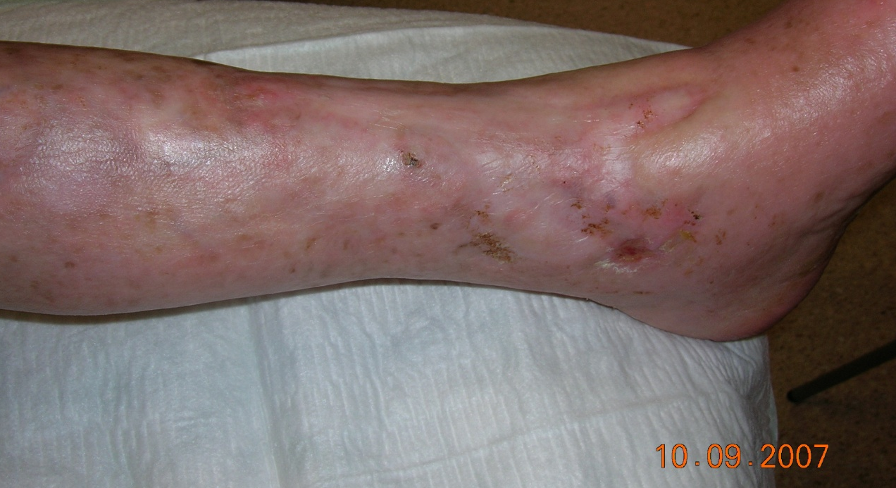
Figur 1c.

There was complete ulcer healing after 16 weeks of treatment with no recurrence at follow up 22 months later.

