Fette VAC pictures (in separate files attached) – please use them in this order

Figure 1 – The fistula network after incision and staining with methylen blue
Figure 2 – The wound after excision
Figure 3 – The wound with the V.A.C.® foam dressing in place

.
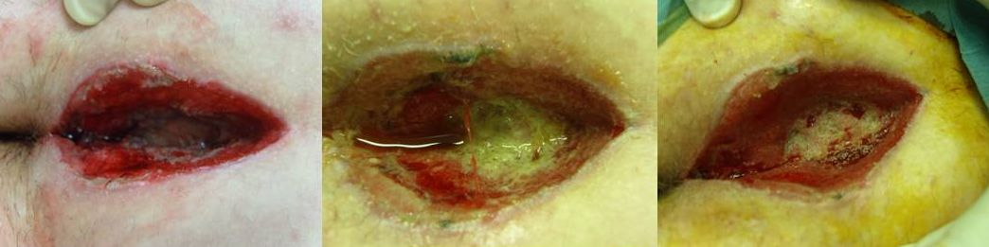

Figure 4 – A sudden leakage of exudate from the wound occurred on the third dressing change
Figure 5 – More exudate, slough and debris was detected on the wound surface on the fourth dressing change
Figure 6 – The wound after complete removal of the exudate, slough and debris on the fourth dressing change

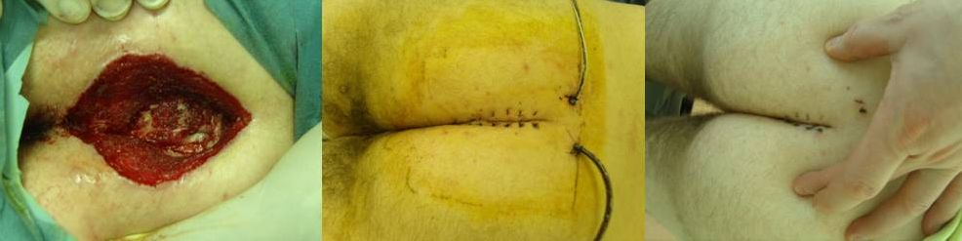

Figure 7 – After 12 days the wound was clean and granulation tissue was present
Figure 8 – The closed wound after 12 days of V.A.C.® Therapy
Figure 9 – The wound after removal of the stitches. After closure, the wound healed without further problems

